David Heisler

Homework 9

4.7

4.18

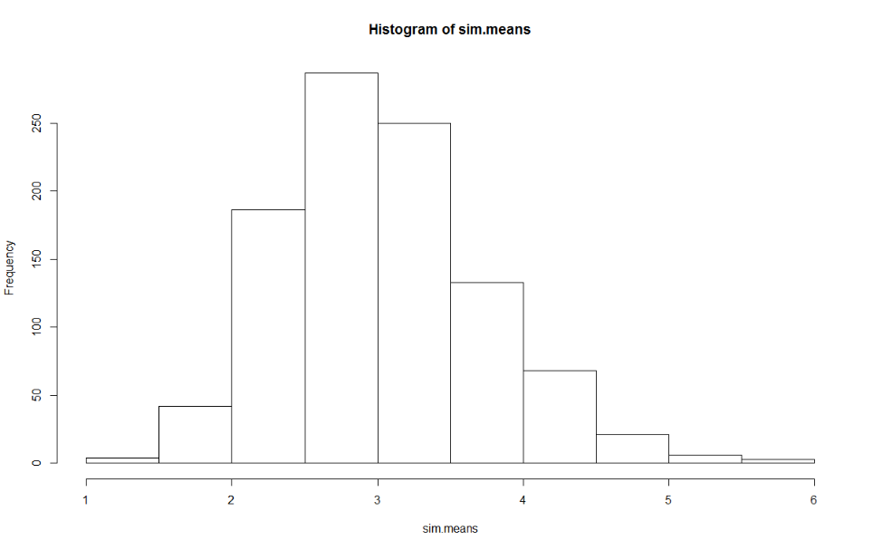a)

Here is my plot of the sample distribution for the sample mean. Note how symmetric it is, which makes sense because of the application of the CLT. Code for this is in the appendix

b)

I found the mean of the sampling distribution to be 3.033727, which is in line with the theoretical result of 3, which we know because the mean of an exponential random variable is the inverse of the rate, in this case the rate is 1/3, which has an inverse of 3. I received a standard error of .7037892. Comparing this to the theoretical result of .6708204, which I found by dividing the standard deviation of our exponential variable – 3 – by the square root of our sample size. Both of these results are reasonably close to our theoretical values, thus everything seems to check out!

c)

Based on my simulation I found a value for the probability of the sample mean being less than or equal to 3.5 to be .769

d)

4.24

a)

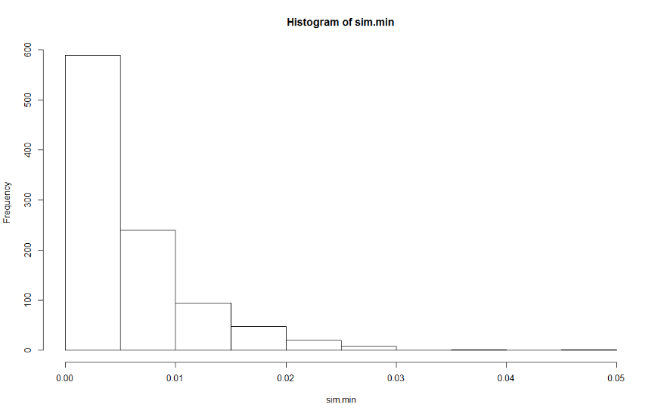b)

Here is a histogram for my sampling distribution – code in appendix. I received an expected value of the sampling distribution from simulation to be .005.

4.29

a)

b)